SYNOPSIS

ON

“AI DRIVEN PERSONALIZED LEARNING AND CAREER PATHWAYS PLATFORM”

Submitted in

Partial Fulfillment of requirements for the Award of Degree

*of*

Bachelor of Technology

*In*

Computer Science and Engineering

By

**(Project Id: 24_CS_AIML_2B_15 )**

# Laxmi Narayan(2301641530103)

# Manas Tripathi(2301641530105)

# Lucky Yadav(2301641530104)

# Nishi Raj (2301641530121)

Under the supervision of

**RAVI KISHAN PANDEY**

**(Designation)**

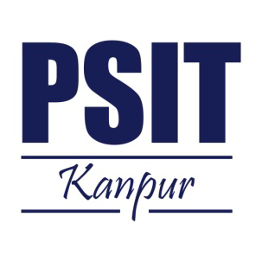

**Pranveer Singh Institute of Technology**.

 Kanpur - Agra - Delhi National Highway - 19

Bhauti -Kanpur - 209305.

(Affiliated to Dr. A.P.J. Abdul Kalam Technical University)

1. Introduction

This project focuses on developing a personalized learning and career pathways platform that tailors education recommendations based on individual progress and preferences. The platform integrates pre-prepared roadmap images and real-time course suggestions by employing web-scraping techniques. The learning model adapts based on users' performance, offering personalized guidance, skill-building resources, and tailored content.

The use of artificial intelligence (AI) ensures that the roadmap and courses dynamically adjust to users’ needs, while web scraping allows the system to extract top-rated courses from various platforms. This project addresses the growing demand for personalized learning systems that help learners navigate complex career pathways in real-time, ensuring continuous learning and growth.

2. Project Objective

* To develop an AI-driven platform that creates personalized learning roadmaps for users.
* To provide real-time course suggestions from top platforms using web scraping techniques.
* To monitor user progress and adapt roadmaps dynamically based on their learning abilities.
* To help users identify relevant career pathways and acquire the skills required for their chosen fields.
* To automate the extraction of top-rated, field-specific courses from sources like Coursera, edX, and Udemy in real-time.

The platform aims to assist users in enhancing their learning experience by providing a tailored pathway that ensures effective skill acquisition and career growth.

1. Feasibility Study:

This study evaluates the practicality of implementing the AI-driven personalized learning platform by assessing the technical, operational, and economic factors.

* **Technical Feasibility:** The project is technically feasible given the availability of machine learning algorithms, web scraping tools, and cloud infrastructure for deployment.
* **Operational Feasibility:** The platform will function smoothly, providing real-time course suggestions and adaptable roadmaps. AI and scraping technologies will automate the updates.
* **Economic Feasibilit**y: The project development costs are minimal, with open-source tools like Python and its libraries, making it economically viable.

**Start Date: 09-Sep-2024 End Date: 30-Nov-2024.**

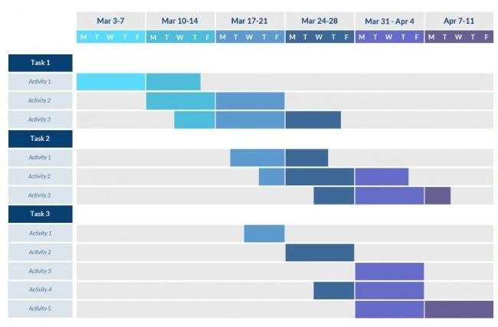

4. Methodology/ Planning of work

The project will follow these steps:

1. Requirement Gathering:
   * Define user profiles, learning paths, and necessary skills.
   * Identify top online course providers for web scraping (Coursera, Udemy, edX).
2. Architecture Design:
   * Build a machine learning model to track user progress and adjust roadmaps.
   * Design web scraping scripts for extracting course data in real-time.
   * Implement data visualization for learning roadmaps (using pre-prepared images).
3. Development:
   * Create user interfaces for personalized dashboards.
   * Integrate AI models to adjust learning pathways.
   * Develop scrapers using Python and BeautifulSoup for real-time course suggestions.
4. Testing:
   * Ensure the platform adapts roadmaps correctly based on user inputs.
   * Test scrapers to verify the accuracy of course data extraction.
5. Deployment:
   * Deploy the platform using cloud infrastructure (e.g., AWS or Google Cloud).
6. Final Review:
   * Collect feedback from initial users and optimize the AI models for improved performance.

5. Tools/Technology Used:

5.1 Minimum Hardware Requirements

* **CPU: Intel Core i5 or equivalent**
* **RAM: 8 GB minimum**
* **GPU:**
* **HDD:250 GB minimum**
* **Others(if any):Internet connection**

5.2 Minimum Software Requirements

* **Operating System**: Windows, macOS, or Linux
* **Programming Languages**: Python (with libraries like BeautifulSoup, scikit-learn, pandas, TensorFlow)
* **Web Scraping Tools**: BeautifulSoup, Scrapy
* **AI/ML Frameworks**: TensorFlow, PyTorch
* **Database**: MongoDB or Firebase for storing user data and progress
* **Cloud Services**: Streamlit Cloud for deployment
* **Frontend Tools**: HTML, CSS, JavaScript (for user dashboard)

6. References:

* Research papers on AI in personalized learning.
* Documentation for web scraping tools (e.g., BeautifulSoup, Scrapy).
* Relevant books and articles on adaptive learning models.
* Websites and APIs for extracting course data (e.g., Coursera, edX).

**Guidelines:**

1) Heading Font Size: 14

2) Content Font Size: 12

3) Font Name: Times New Roman

4) Line Spacing: 1.5”

5) Alignment: Left & Right both Justified

6) Margin: Normal (Top=2.54 cm, Bottom=2.54 cm, Left=2.54 cm, Right=2.54 cm)

7) Page No: At Bottom Right Side

Note: Consider this format for your reference.